The Lord’s Fire.1
“ Is not my word like as a fire saith the Lord the hammer that breaks the rock in pieces.
Jeremiah 23 v 29

Pastor Joseph was talking as the auto rickshaw jolted and swayed. Tony’s back was hurting he clung on listening as Pastor Joseph told him that the village they were heading for was a notorious place for the occult. He said that the area was notorious for the occult and that the manifestation of demons was common. Brother Tony was disturbed as pastor continued talking of demon possession and drunken orgies and more. “ Brother please stop” I want to tell them of the Love of Jesus”
Arriving at the village Brother Tony was led to a central place where a single
neon light was strung up giving off a weird light and attracting hundreds of mosquitoes. slowly the mats filled up with women and children with a few men at the back.

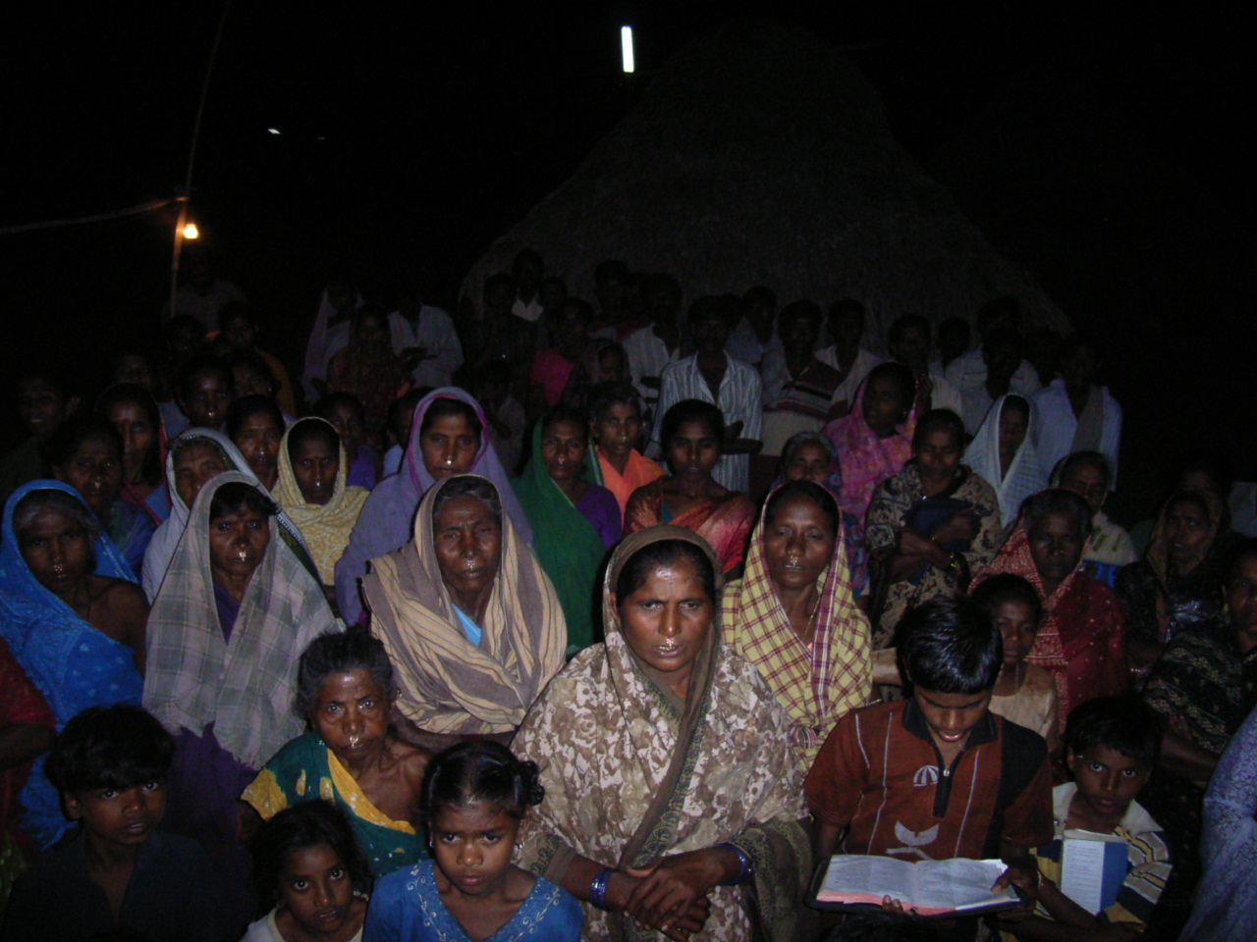

The meeting commenced and it was not long afterward that a woman was causing a disturbance. It happened suddenly and brother Tony rebuked the woman and commanded her to be quite in Jesus name. The translator rebuked the woman in the same Spirit and with the same strong righteous anger.
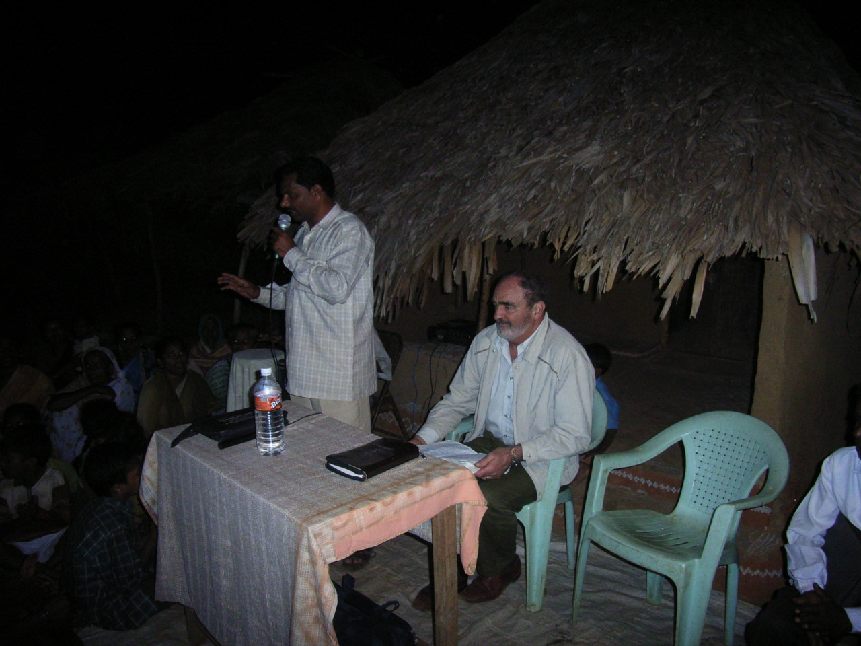

The meeting continued without any further interruption and the word went forth in power.. After the meeting concluded pastor Phillip distributed the sacks of

rice and brother Tony slipped away to find a place to pray. Later the translator
came to seek him out. He told brother Tony that pastor Phillip had seen fire come out of the preachers mouth, not only that but that pastor Phillip had also witnessed fire coming out of the mouth of the translator.

Brother Tony was shocked and wondered . when the messenger had gone he asked the Lord .. Lord what is this. The Lord spoke to brother Tony “ Is not my word like as a fire saith the Lord the hammer that breaks the rock in pieces. Brother Tony was meditating on this as he returned to the city.. in the coming months he wondered and thought over the events of that night as he had never rebuked anyone in Jesus name before, and had not planned to.

As it happened a year later brother Tony happened to be in that city again and was invited to return to the same village. When he arrived pastor Phillip greeted him and took him by the arm and said “Come with me” . it was dark and pastor Phillip led the way over what seemed to be a piece of rough ground. Brother Tony had a torch in his hand and was startled when pastor Phillip said , “ Look” brother Tony looked but could see nothing. “Look” “Look” it was

pastor Phillip gesticulated , pointing his finger in the dark. Brother Tony was
confused he could see nothing. “ Look” came again this time pastor Phillip was bending low over the rough grass. Bother Tony looked and discerned a flat piece of cement. What was this ? What did it mean?

In a flash brother Tony realised that pastor Phillip was pointing to the remains of the foundations of what had been a village hut. Yes the cement base. Pastor Phillip was explaining the village had been destroyed in a fire what remained was the cement bases of the huts..
The village had been a bastion of evil. The Lord had sent a messenger with a warning message. This had been ignored and the Lord had sent fire.

Jeremiah 23 v 29 “ Is not my word like as a fire saith the Lord the hammer that breaks the rock in pieces.

