The Lords Fire.1
And there went out fire from the LORD and devoured them, and they died before the LORD. Leviticu10 v 2
“ Is not my word like as a fire saith the Lord the hammer that breaks the rock in pieces. Jeremiah 23 v 29

Pastor Joseph was talking as the auto rickshaw jolted and swayed. Tony’s back was hurting he clung on listening as Pastor Joseph told him that the village they were heading for was a notorious place for the occult. He said that the area was notorious for the occult and that the manifestation of demons was common. Brother Tony was disturbed as pastor continued talking of demon possession and drunken orgies and more. “ Brother please stop” I want to tell them of the Love of Jesus”
Arriving at the village Brother Tony was led to a central place where a single neon light was strung up giving off a weird light and attracting hundreds of mosquitoes. slowly the mats filled up with women and children with a few men at the back.
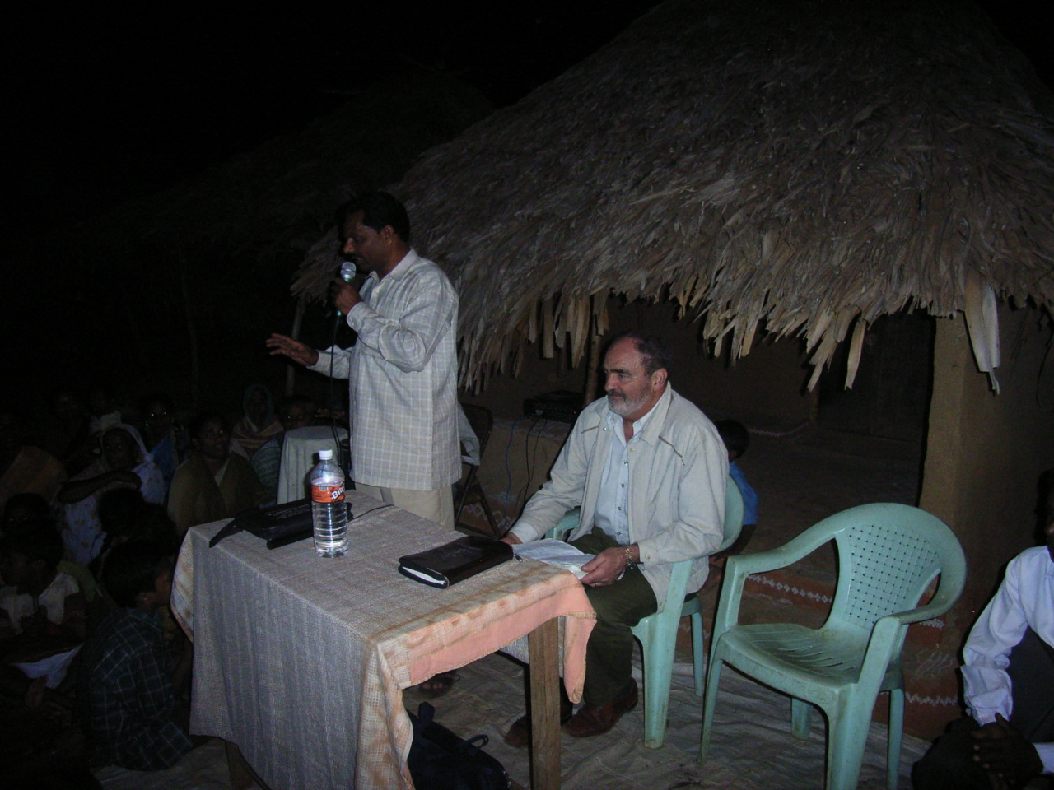
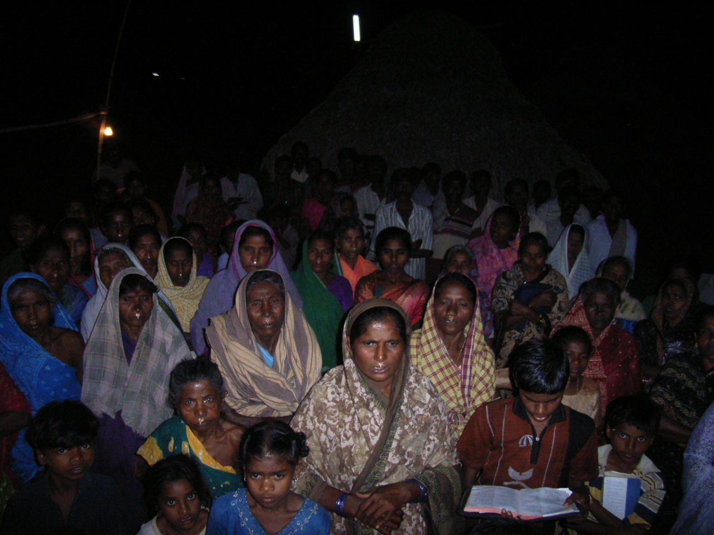

The meeting commenced and it was not long afterward that a woman was causing a disturbance. It happened suddenly and brother Tony rebuked the woman and commanded her to be quite in Jesus name. The translator rebuked the woman in the same Spirit and with the same strong righteous anger.

The meeting continued without any further interruption and the word went forth in power.. After the meeting concluded pastor Phillip distributed the sacks of rice and brother Tony slipped away to find a place to pray. Later the translator came to seek him out. He told brother Tony that pastor Phillip had seen fire come out of the preachers mouth, not only that but that pastor Phillip had also witnessed fire coming out of the mouth of the translator.

Brother Tony was shocked and wondered . when the messenger had gone he asked the Lord .. Lord what is this. The Lord spoke to brother Tony “ Is not my word like as a fire saith the Lord the hammer that breaks the rock in pieces. Brother Tony was meditating on this as he returned to the city.. in the coming months he wondered and thought over the events of that night as he had never rebuked anyone in Jesus name before, and had not planned to.

As it happened a year later brother Tony happened to be in that city again and was invited to return to the same village. When he arrived pastor Phillip greeted him and took him by the arm and said “Come with me” . it was dark and pastor Phillip led the way over what seemed to be a piece of rough ground. Brother Tony had a torch in his hand and was startled when pastor Phillip said , “ Look” brother Tony looked but could see nothing. “Look” “Look” it was pastor Phillip gesticulated , pointing his finger in the dark. Brother Tony was confused he could see nothing. “ Look” came again this time pastor Phillip was bending low over the rough grass. Bother Tony looked and discerned a flat piece of cement. What was this ? What did it mean?

In a flash brother Tony realised that pastor Phillip was pointing to the remains of the foundations of what had been a village hut. Yes the cement base. Pastor Phillip was explaining the village had been destroyed in a fire what remained was the cement bases of the huts..
The village had been a bastion of evil. The Lord had sent a messenger with a warning message. This had been ignored and the Lord had sent fire. Tony Jeremiah 23 v 29 “ Is not my word like as a fire saith the Lord the hammer that breaks the rock in pieces.

Lost and Found. 2
"Behold, I send you forth as sheep in the midst of wolves. Be ye therefore wise as serpents and harmless as doves. Matthew 10 v16

It is Chaos. The call comes for those passengers with numbers from 1 to 24 to go to doors. Of course there is a rush for the doors and a complete jam. I wonder if we will get there at all. Two buses are waiting outside we clamber aboard. Eventually we all get on the bus after pushing and shoving then drive out to the plane. A woman loaded with a huge heavy case tries to struggle up the stairs while we all wait.

Eventually a man helps her and I gradually mount the steps and sigh as I locate my seat and look out onto the tarmac. We took off and I had a cup of coffee then tried to doze until we reached Chennai. The Lord drew near and I had a wonderful blessing. I know all will be well tonight. The plane is descending and I look at the lights of Chennai dropping suddenly to land on a wet runway in a humid temperature of 31 degrees
Alighting in the luxury of warm air, I clambered aboard another coach to the terminal building. After having my passport stamped without any fuss I waited in the baggage reclaim which I noticed had improved somewhat since my last visit.
There were two carousals in operation, which meant going backward and forward to each, peering to see if my case was there. There were the usual huge crates and bundles of luggage of all shapes and sizes, the bigger ones getting jammed on the conveyor belt but no sign of my case. I was getting concerned. I was just beginning to wonder what I would do without it, without a change of clothes, when suddenly it appeared. With heartfelt relief I breathed a "Praise the Lord" grabbed it and went out through the exit to meet the huge crowd gathered waiting for folk's.

Refusing all taxi offers and helps from porters I made my way the 200 meters to the domestic airport to find a seat to rest on. I checked at a money exchange and was horrified to find the exchange rate was R48 to the pound, what dreadful robbery. I have taken a photo in Chennai and now in the domestic flights lounge. It is very run down. My head is woozy as waves of tiredness sweep over me. I try resting my head on the case, like the kitchen table but it was no good., then I try lying back in the seat, still no good I groan five more hours to wait

The time drags on and on. At 10 30 AM. I enquired at the desk no another hour before the desk opens, I return to sit again. At 11 30AM I check my case and go upstairs to the departure lounge. It is empty and I am told by the guards to sit down and wait. I am tired of sitting down, I'm tired of waiting. The time drags, slowly others join they and me too are told to wait. Several idle soldiers come and go slowly, very slowly as if devoid of any energy.. Then we are allowed to go in to be searched. They are very thorough and I almost have to strip undoing my trousers to show my money belt has a zip which has caused his bleeper to bleep. Once more we sit waiting. I go to the washroom and try to freshen up.

The plane my third is very quick hardly have we ascended when we are descending and I can see the rice fields and buildings of Bangalore. At the baggage claim I wait for my case. I can see people watching me through the open doorway. Foolishly I wave. No one waves back. The sunlight hit my eyes as I leave the building and meet the usual clamor of demanding taxi drivers touting for business and others seeking a buck. A ferocious police sergeant with a big stick drives away some unwanted tricksters. Some still get through and I tell them rather smugly that "I have someone to meet me". Sadly as I wait it dawns on me that this is not true. I scan the remaining placards for "Tony Daly", but there is no sign of it. I wait. "Lord what to do I pray". I realize that I have no rupees, that I have only the address of Pastor Jackson. I search through my pockets to find the address. A friendly taxi touts hovers nearby. I tell him of my predicament. "Could he take me to this address? I only have English money? Yes. How much I enquired? "I have a meter he replies. I hesitate. "Could you take me to where I can change some money? Yes but the bank is shut at the moment”.

Then after a little discussion with an airport guard I am allowed back into the airport and shown the way to a money changers booth. The rate is R67 to the pound. Wonderful! So I change £100. Now returning to the exit I am led to a beaten up old taxi and my case is loaded into the boot. As we meander through the traffic I realize I cannot see a meter. "Where is the Meter I ask" The taxi driver hunts under the dash, producing a booklet with destinations. I find Ulsoor and note that it says R300. I work this out at £3/4 so it is not too expensive.. After a while we come to a stop. We are lost. The driver gets out to ask the way. There is a lot of pointing and gesticulating. One man says this another that. When all is finished another one joins in and off we go again, more gesticulating.
The taxi driver returns we start to drive across the road. Now is the time to pay he states. We turn into a compound and stop. I look amazed for there is a building with a Christian meeting-taking place. The taxi driver turns and says R 650. I am not shocked I say, “No way, I will call the police. You said R300 and R 300 is what you will get”. I realize that my smallest note is R500 so I get out to ask someone for change but look back fearing the taxi will go off with my luggage. Three young men are waiting at the entrance and I ask one for change. I pay off the taxi and write a note to Pastor Jackson, "Tony Daly. I have just arrived", I give this to one of the young men to take to the Pastor and off he goes. I take the opportunity to look around.

Family meeting

The meeting place is large perhaps holding two thousand or more souls. I am on the platform sitting looking at the crowd a German brother Alexander is peaking. He seems to be struggling with his message. Then suddenly Pastor Jackson is introducing me and I stand at the pulpit to deliver my message. The Lord gives me liberty and love to proclaim the Gospel my translator is good and the Word goes forth with power and love. Praise God.

“Orphans Home”.3
In My Father’s house are many mansions; if it were not so, I would have told you. I go to prepare a place for you. John 14 v 2

15th Jan. I was greeted on my birthday with the orphan children sing a happy birthday. I opened my birthday card from my case. I had been to town on the back of Joseph’s motorcycle to send emails at the internet café . Joseph had kindly bought me an Indian suit and I wore it for the children’s meeting. The Lord helped me to give the Word 2 Chron 9 v 1-7 …”Happy are these thy servants” and Mephibosheth invited to the Kings table… As I preached looking at the faces of these dear children drinking in the Word of the Lord hungry for blessing the Holy Spirit anointed the Word and at one time the translator broke down deeply moved. He was weeping openly and Sunitha attempted to continue with the translation but soon she too was broken by the message of God’s love. Soon the present writer was also weeping as the spirit of God swept over us….
The Vision.4
Where there is no vision, the people perish; Proverbs 29 v18

In 1977 the Lord showed me part of His future plans for me. It happened when I was asleep in my bed. The Lord gave me a vision.
In the vision I was on a platform, singing and preaching the Gospel and I could feel the heavy anointing upon me as I sang and spoke. As far as I could see in front and on either side of me there were people, dark skinned people. It was such an amazing sight that I could not bring myself to tell anybody of this wonderful happening. I treasured all these things in my heart. (Luke. 2 v 51 N.I.V.)

Sometime in 1982 Sheila and I came to know Brother Joshua Daniels, a man of God from India. God had already used him mightily to bring lost souls to Jesus through revival meetings in India and around the world.
In these meetings in England Sheila and I would sing and testify to the greatness of our God. Brother Joe invited us to go to India to sing and minister to the people. We prayed and asked the Lord

The Lord said, ‘No go to Poland.’ So I went to Poland! The Lord showed my amazing things in Poland with congregations of Pentecostal believers broken by the Word of God and weeping and sobbing openly.
The Lord had given me a warning message “ Why have you lied to the Holy Ghost” Many were repenting of secret sin and sometimes open sin… One year passed.
We were invited to India again and we asked the Lord. ‘Lord, India?’
The Lord heard and answered, He said, ‘No, I want you to go to Southern Ireland.’ I had a word of confirmation “Go to the land of thy fathers” Genesis 32 v 9 I travelled to Cork around Ireland to Dublin where I preached 11 times and returning via Wexford and Waterford giving out gospel tracts land sowing precious seeds.
Another year passed.

We had yet another letter inviting us to India, again I asked the Lord,
‘Lord India?’ He answered me and said, ‘No. I want you to go and preach the Gospel to a hundred English towns and cities.

I was stunned and said “Lord it is impossible, I cannot do this” The Lord answered “go and I will show you my Glory|” I submitted immediately and wonderfully the Lord led me to a hundred English towns and cities. Many years passed. Had I missed the chance? Had I unwittingly bypassed God’s will, His perfect will? One morning when I was in prayer I knew it was God’s time for me to go to India. I didn’t have to ask the Lord to confirm it, this time, I knew. I told no one, not even Sheila, I kept this secret hidden in my heart. A month went by. One morning Sheila and I were praying together about another visit to Poland. Sheila said, ‘And India.’ I looked at her and silently asked, ‘Lord, how did she know?’ He spoke to me in a whisper, ‘The same Spirit that told you, has told her.’

In January 1998 I met Brother Joe at a retreat in London . After sharing
the plans that God had revealed to me regarding the visit to India the way was miraculously opened for my appointment with India. I marvelled that God’s timing and plans were so precise. I had asked to talk with brother Joe Brother as I had been arranging a visit for him to go to Lublin in Poland. This was to be on the 15th of May that year

When talking with Brother Joe there seemed to be some misunderstanding as when I was speaking to him of the 15th May he said “No brother the 15th January. I was confused, surely Bro Joe understood. But it was not him, but myself that was confused. He said, “Yes Brother the 15th January and India”. I was shocked. India.

I had no money, no visa, no air ticket. How could this be? I left brother Joe still wondering but I need not have concerned myself as the Lord had everything arranged. It was an impossible situation with only a few days to get organized. Yet the Lord arranged a visa a passport and the airfare and on the 15th January, my birthday, I flew to India arriving in Chennai. The following is my impression taken from my journal.

“The heat enveloped me as I joined the long queue disembarking from the plane at Chenai (Madras) airport in Andrea Pradesh. Waiting at the baggage carrousel I was dismayed at the confusion and apathy. An antiquated conveyor belt was whirling around disgorging weird sounds, groaning as and screeches. I wondered whether it was safe. As we stood steaming in the afternoon heat bags, boxes, suit cases, parcels of all shapes and sizes, suddenly appeared through the rubber shield. Several disinterested soldiers stood leaning over a television monitor standing on a table. It was impossible to see how such large and unwieldy packages could be screened at all.

Crates with chickens, tires, all sorts of roughly bound cases and bulging wooden crates appeared, one after the other. A sudden loud screech, the machine shuddered, half stopped, picked up speed again, then with a final screech it came to a halt. The inevitable had happened. Boxes fell off the conveyer and fell into the dust. No one moved. Where was the engineer or the service man? Lost somehow back in the mist of time?
This was my first visit to the sub-continent of India. I was in for a cultural shock in the next few weeks! Looking around at my fellow travelers I noticed I was the only one wearing a jacket.
I felt out of place, Seiks, Muslims, Hindu’s and a smattering of Europeans with some colourful African people and Moroccans, we made and interesting crowd. I wondered idly what the reaction would be if I should suddenly burst forth preaching the Gospel. How long would I live?

After an interminable time, an engineer came rambling along and sauntered through to the back of the machine. It took ten minutes before it rumbled into life again. After a few kicks at the cases still clogging the works, the right luggage somehow married up with the right people and everybody made for the exit.
Chennai .5
Now while Paul waited for them at Athens, his spirit was stirred within him when he saw the city wholly given to idolatry. Acts 17 v 1

“Mad dogs and Englishmen go out in the midday sun!” Looking back, I must have been mad to venture out that afternoon, to leave the safety of the LEF Headquarters building. It was very hot but I had reasoned that I was only going to be in the city for a few days and I did want to explore and take photos.
I was aware of the natives and their incredulity as I passed by wearing a sun hat and dark glasses. I must have caused great amusement to them. Shutting the gates behind me and leaving the compound I headed for the main road. The side street was filthy dirty. Groups of men were eating food from the street stalls, indifferent to flies and horrible smells. The turbaned drivers of the yellow three wheeled taxies accosted me, imploring me to hire their vehicle but I waved a dismissive hand turning left into the hub-bub of the city.

I gazed in amazement, right and left, up and down. Hindu temples, wandering beggars ,”animals,” the constant bleeping of scooter and car horns in the melee of the city traffic was intoxicating. I tried to ignore the piles refuse, the dangerous pavements, the potholes and the awful stench. I entered a book shop finding temporary relief from the overpowering heat . It was another world.

Security guards opened the door and greeted me before ushering me into a haven of air-conditioned luxury. I relaxed as I walked up and down rows of books, maps and other things, comparing prices, surprised

and yet disappointed that it all looked so normal - just like “Smiths” in England! Back in the hot dusty street, clutching my maps and envelopes, feeling a little pride at having negotiated my first purchases. I retraced my steps and found Thompson’s travel agents where I changed £100 to 6,500 Rupees. Feeling more confident, I located the post office situated on the ground floor of a large office block.

It was bedlam! Stamps were bought in another room off a long corridor. After queuing to buy them I was directed to another queue. In the same room, where you had to pay for them. It was no surprise to find the mail had to be posted in another room further down the corridor. Having completed my mission, I went out again, crossed the busy road finally returning to the compound and the cool of my room with thankfulness and relief. My room was very basic having cement walls and ill fitting wooden shutters over glassless windows. A solitary bed placed in the centre of the room with its “mosquito net ties strung out to the window frames inviting unsuspected guests to hang themselves in a forgetful moment! The room did have one redeeming feature - a giant air conditioning unit.
On being shown the room, the boys had taken pity on me. They had seen I was sweating profusely and had called for an electrician who had rewired the unit. There was only one disadvantage, when in operation it emitted a ghastly noise, rattling and rumbling, so you had to choose - be cool and deafened by the noise or bake in the heat and enjoy the quietness, whichever you needed most. That evening I stood on the balcony, overlooking the street, wondering what the Lord had in mind for me in India.
LEF.6
Let your light so shine before men, that they may see your good works, and glorify your Father who is in Heaven. Matthew 5 v16

FIRST MEETING IN L.E.F. HEADQUARTERS, MADRAS
The headquarters building in Madras towered high at 9B Nungambakkam High Road with The facade proclaiming in huge letters Christ with smaller letters above
Christ: Light,Love,Life

I entered the cool main hall at around 7.30 p.m. and joined the group of students and older folks gathering on the mats placed to one side of the
hall at the rear. A microphone and speakers had been set up and a chair placed for Brother Joe. Other chairs had been set out for the older folks at the back. I sat with the others crossed legged. The women were seated together on my left across a gap left in the matting. Many were already in a position of worship and quietly waiting upon the Lord. When Brother Joe came in he asked if I needed a cushion. I declined and was touched at his concern although I knew this was his way of saying hello.

Brother Joe led the prayers and others quickly followed in succession
pouring out their hearts to God. I believe the revival meetings that followed owed all the blessings received to these simple yet powerful and continuous prayer meetings. The next morning I was on the platform for the 9 A.M. English speaking meeting. This was followed by another meeting at 11 a.m. interpreted into Tamil by a short, powerfully spoken, erudite Tamil. A baby was dedicated to the Lord, followed by Pastor N. G. from Singapore, preaching. I sang "My Saviour is leading me" and "He Lifted Me" both with much anointing from the Lord.

In conclusion Brother Joe spoke from a high platform wheeled into position at the last moment. This is so that those occupying the galleries could see the speaker. I was told the hall could hold 8,000 folks and certainly the courtyard was crowded with thousands of folks when the service ended. That night it was a joy to stand on the platform in Royapurram. I arrived safely after being driven through 'life threatening traffic' to be introduced to Dr. Jayasighn, his wife, family and the team.

Looking across at the garden pandal, already partly filled with the colourful sari's of the women, the palm leaves waving in the breeze wafting in from the Indian ocean and the choruses already drifting over the garden. I was enthralled by the noise, colour and the gentleness
God's presence was palpable and his love filled my heart as I sang "By the marks in His hands" and "Woman at the Well".

The Lord gave me a message Matthew 11 v 5 “The blind see” and gave me much liberty to preach. After I had concluded there were many folks desiring prayer and I was humbled by their simple yet strong faith. As I returned through the city to headquarters I was filled with a great joy and
peace and rejoiced in God's rich blessing in my heart. It was beautiful.

Brother Joe’s father, Joshua Daniels senior dared to take the Gospel into that place. The hand of God was upon him. Not only did he have divine protection but he was allowed to preach the Gospel of Jesus Christ.

Some of the villains who had committed murder in the past were convicted of their sins and gave their hearts and lives to Christ. They began to preach the Gospel of Christ and He crucified. They introduced annual meetings beginning with just a few people attending; the number grew to about a hundred. The numbers have grown over the years and now over a 100,000 gather to hear God’s Word. These people were mainly Hindus and Muslims who have accepted Jesus Christ as their personal Saviour.

They are happy to sit day after day in meetings which last for many hours listening to the simple but powerful Word of God. One morning while attending the pastors prayer meeting where 200 pastors and evangelist meet to pray. Bro Joe asked “Brother Tony, Do you have a word from the Lord” I answered “Yes brother” Brother Joe said “Go and prepare your heart” and then I knew the Lord opened the way for me to sing and preach to a vast crowd estimated to be in excess of 100,000.This was the fulfillment of the vision that God had given me all those years ago. Glory to God, He gave me such love and such joy.
The Lord reminded me of His Word in Habakkuk 2:2
“And the Lord answered me and said, ‘Write the vision and make it plain on the tables, that he may run that reads it. For the vision is yet for an appointed time, but at the end it shall speak, and lie not, though it may tarry, wait for it, because it will surely come. It will not tarry.’ K.J.V. the next day I visited Vijahawadda.

Vijahawadda.7

And the common people heard Him gladly. Mark 12 v 37

The station at Chirala was crowded with sleeping figures in the foyer. I had left Stuart Purram by train and had arrived the previous night feeling extremely tired but there was nowhere to rest. The train I had waited for during the past hour had been delayed and when it did arrive I had to run to the front of the train to find the European air conditioned car. John, and I settled down to rest. . I was concerned we would fall asleep and miss Vijahawadda station where we wanted to alight. John reassured me we would be notified when we were about to arrive in Vijahawadda. We were met by hotel staff at 9.30pm. who escorted us to our rooms in a beautiful hotel. Supper of bread, cheese, boiled eggs and apple juice awaited me. I had the hot shower and air conditioning all to myself and it was wonderful. I slept quite well only waking up about 3am. After breakfast in my room I was informed that I was expected to sing and preach that morning at 9.30am.

John and I took a “Yellow Peril” auto rickshaw through the morning traffic to find a crowd of about 2,000 people waiting. The Lord had given me a Word during the night and I awoke to receive this message:
A great Vision; A great Division; A great City.
I was introducing the song I was going to sing when the electricity failed. The leader encouraged the folks to sing a chorus, “The love of Jesus is so wonderful,” until the power was restored. Then I sang another song, “By the Marks in His hands you will know Him ,” and gave the Word.
After a further power cut I was asked to sing, “He lifted me.” Brother Norman Duncan preached after that. The programme seemed too long, certainly by European standards but the people were absorbing the Word and seemed very happy to listen. In England there would have been shuffling and folks leaving to go home and put their dinner on to cook, tut-tutting as they left.
We concluded about 2p.m. There was a crowd of people requesting prayer. Brother Norman and his wife were busy counselling folk and I too was asked to pray for them. Later we shared a meal with Brother Francis, Norman and Joan with Brother John and his wife waiting on us.
The next meeting was at 5pm., we were to be picked up at a quarter to. The meeting actually started at 6.15pm. I sang “Oh, Woman at the well,” and shared this testimony .

--------------------------------------------------------------------------------

Brother Francis was speaking when the tape recording machine broke down. He asked me to sing again while they repaired it. My song was “I heard Him call.” Brother Joe arrived on the platform while I was still singing.
When he started to preach the Word, I left the platform choosing to join the men who were listening.’ The crowd stretched far behind me afterwards, Brother Francis Daniel told me it was 10,000 strong.

Beaulah Gardens.8

He taught them as one having authority, and not as the scribes. Matthew 7 v29

Georgie and Grenalah were waiting for me when I arrived at Madras Central Station. They took my cases and led me to their car. We drove through empty city roads to headquarters. The driver gave three warning toots as he approached the gates, slowing down he repeated the three toots and the gates opened automatically. Truly a royal welcome.
I joined the Saturday ‘fasting and prayer group’. I did pray but I was tired and felt jaded and my prayers seemed stultified.
Sunday morning, Headquarters, Madras.
I woke up at 5.30am. with an upset stomach and feeling very unwell. I took two of the tablets I had brought with me for such an eventuality. I struggled to get a Word from the Lord but… so I prepared my heart with; “If ye be willing and obedient, ye shall eat the good of the land but if ye refuse and rebel…?” I really felt queasy and ill, I took two more tablets and prayed.
The meeting commenced at 9am.with the Tamil service, then continued with the English service at 11am. The Lord helped and sustained me .
After the meeting two brothers were waiting for me, they asked for prayer. One of them was my interpreter from Royapurram, the other brother was in charge of one of the centres. David Paul had prepared a list of his family for my future prayers. After dinner I was resting in my room when the ‘phone rang.

‘Brother Tony, could you be ready to go to Beaulah Gardens at 5pm.? Could you give the Word at the meeting?’The traffic was horrendous but with God’s help we arrived safely. Beaulah Gardens is a beautiful banana plantation covering many acres. Brother Joe showed me the new roadway, recently built to avoid the flood waters. ‘The people are simple village folks,’ Brother Joe had mentioned to me earlier, so I felt the message I had already prepared was unsuitable.

Palm trees gave shelter and I walked up and down amongst the trees in the cool of the evening, seeking the Lord’s face and His will, changing my message to a more appropriate one. A small pandal had been erected with matting laid out to seat about a hundred people. The praise and worship songs and the singing were enthralling. The scene was beautiful. The blessing of God was upon us. How wonderful to see these villagers gathering around to hear God’s Word. The Lord gave me a great love for them as I sang and testified. I told them of the “black cat” and preached on, “What manner of love the Father has bestowed on us.” Brother Joe then gave his message. The meeting closed about 8pm.
I walked among the trees again, giving thanks to God. As I retraced my steps back to the pandal there were a small group of men waiting for me to pray with them. There were still many people waiting outside Brother Joe’s room where he was engaged in personal work, counselling and praying with folks.
I left to go back to the hotel and began to prepare for the Bible Class on the next day. I prayed, ‘Lord, please help me.’

Monday 2nd February, 1998
I slept until 3.20AM . It was so hot I could hardly breathe. I put on the air conditioner and dozed until 6am. Then I got up and continued with the preparation for the Bible Class. My head was fuzzy.
Commending the day to the Lord, I asked Him, ‘Lord, what do you have in mind for me today?’ It wasn’t long before I found out. The telephone rang.
‘Brother Tony, could you be ready at 8.15? Brother Joe is taking a wedding service.
Once again I was in the Mercedes wedged between Brother Whitson, Paul and Brother Grenalah. We threaded our way through the city traffic until we came to a traffic accident. A yellow peril had collided with a poor rider on a moped. It took a long time to pass the collision. Everybody in the car prayed for the injured.
Eventually we drove into the compound of one of the centers of the L.E.F. A young man from the Bible College was going to be married. The young man’s father had been involved in the original “Revival Meetings” fifty-six years previously in Kakinada. It was a special time of blessing for all. I was asked to read the Word and was blessed by this privilege as I was a total stranger.
It was after lunch before I returned to Headquarters and was able to rest before continuing with the preparation of my message for the evening Bible Class.

The Lord had already given me the message which was “Our Lord is a consuming fire,” now He helped me to complete it.
Shortly after Bible Class I visited Joe in his den, we prayed together. Then it was time for me to be taken to the airport in the car.
What an amazing time I had experienced in India. Looking back I thank God for it. I never would have believed that I would live to see such things.
All glory to God!

“Parchew”.9
"Behold, I send an angel before thee to keep thee in the way, and to bring thee into the place which I have prepared. Exodus 23 v 20

We set off for the station in a taxi as the car was not available I paid the driver with a dirty R100 note.

Later at the station I watched again the crush of humanity and the melee that is normal life for the Indian. The smells of food cooking at the station, the constant announcements in various dialects, food vendors
crying out, the families waiting, people pushing, and the constant cry from people selling coffee, coffee-cofee-cof-eeeee The in-fighting when a train arrived with folks struggling to get off while others pushing there way on and a stand off when deadlock came!! I was fortunate because I had an air conditioning carriage I said goodbye and settled back to enjoy the journey. Sadly you cannot see out of the windows which are colored brown yellow with grim and age.

I arrived in Rajahmundry and was met by Pastor Joseph and John and two of the children. When we arrived at the orphanage they gave me another welcome with singing and Hallelujah’s ringing out. The older
ladies’ beaming smiles and their worn crinkled hands reaching out to touch me..
Parchew, had prepared some food, chips cauliflower covered with sause, carrots and cabbage. The cauliflower was a yellow colour with a milky thin sauce. The carrots and cabbage hot with spice..However I did enjoy the meal the hot spice doing my throat some good. P.T.L.
Soon I was back in the van and heading for the tribal region. It was a
long, long journey 60 klm and along rough tracks. It was good to be in the real India. The countryside is refreshing the rice field the water buffalo the villages and river, the rocks and dried up riverbeds reminding of the flood that come every August..
We stopped at several places to pick up others, to pray with folk. In one
village it was dark I was told the people were so poor that at the collection on Sunday, the folk could only put in gifts of R5 or R10 . The Pastor could not possibly live on this? I gave one such pastors wife R500. I was told that there are still wild tigers who come to kill the village cattle at night also there are wild bear in the night too.

Eventually we arrived in Annavilprasad village the dark. I started to prepare for the meeting. Apparently we had been expected two hours before and the poor people had gathered but then gone away.. Now I sat outside while the mats were laid on the ground and a young man tried to fix a faulty light bulb fitting.
It was an eerie scene with small pools of yellow light in the darkness of the village.. Slowly the people gathered and I commenced my Word.
I got under way but there was a disturbance and some folk were talking. I rebuked them and got their attention again. I preached on the “Midnight Cry” When I see the Blood I will Passover was at midnight. Oil. The foolish virgins were caught without oil at Midnight and Joy. Paul and Silas were in jail and sang praise to God at midnight. The Lord helped me greatly.

At 9 PM we were heavily engaged in prayer and then the doctor gave out medicines after a cursory examination. Around 10 PM we set off again and arrived in another village. I was asked to give a word in a hut.

This was strange as the pastor had to go and wake up the people and bring them from their sleep. However the Lord gave me a Word. The lessons of Amalek Gal 5 v 16 If we walk in the Spirit we shall not fulfil the lust of the flesh.. “Thou shalt hear |word behind thee saying this “This the way walk ye in it””Isaiah 30 v 20 .

Later as I prayed with the folk at the end of the meeting a woman started to moan. It sounded demonic to me. This increased in intensity until she was in a hysterical state. No one seemed to think this at all extraordinary.
When I prayed for her she fell uncontrollably to the floor unconscious. I told the shocked folk to give her some water. We had to leave then and proceeded to the next village.. where the people were
called from their huts. It was 11.30 PM. I was amazed. Would I give a Word.. I guess some came from their beds.. Anyway I preached on suffering and after again prayed for many in need. One elder was paralyzed but the Lord wonderfully guided me in prayer. The doctor meanwhile was dispensing medicines and the folks came to me for prayer clutching tablets and bottles. Some requests for prayer were very wonderful, asking for wisdom, a double portion of His Spirit, strength to serve the Lord. So it was after midnight we boarded the bus for the return journey. We could not sleep or even doze as the bus lurched and swerved over the rutted road sometimes not slowing for a bump which lifted you out of your seat and nearly threw you to the floor.

On the return journey we were waved down by men in the middle of the track, a fire was burning and they were obviously worse for drink. It looked ominous and the hairs on the back of my neck stood up. The men had surrounded the van they were gesticulating no doubt angered by the sign written on the side of the bus “Jesus Christ is Lord”. Suddenly a man was banging on the door , I shouted to the driver in English “Go, Go,Go.” There was no need for translation as he knew what was needed. Somehow with the Lords help our experienced driver managed to force the van through the men crowding around slowly at first and then with increasing speed drove off into the night.

As we neared the city outskirts a warning red light illuminated the drivers dashboard. The engine coughed and then died ,. The only sound was the swish of the tires on tarmac as we slowed and then stopped.
We were all tired and this was the last straw. What to do. Someone suggested we pray and quietly we asked the Lord for help.

After our almost whispered prayer there was silence and no one moved. I suggested that they tried to start the van. We held our breath, “would it start”. No there was no possible way. We all gratefully praised the Lord as the engine sprang into life and we set off once more.
Then the red warning indicator light returned and illuminated the scene. Lord please keep us going. Strangely we were not at all disappointed when the engine died once more and the only sound was the swishing of the tires. It took several minutes before we realized that the van was rolling on a slight slope. We turned left then right and yes we still rolling silently through the darkened streets. I had no idea where we were and was preparing myself for perhaps a walk when we turned left the right then right again and cam e silently rolling to the outside of the Orphan Home.

Eventually we arrived in the City at 1 45 AM I was just putting up the mosquito net when there was a knock at the door and Parchew had brought in a beautiful omelets 3 slices of toast and tea. Amazing I tumbled into bed exhausted...
I was up during the night a 4 AM to switch on the fan because of the
stifling heat and bad air.. Then I dozed until 6 30 AM to be woken by the orphan children singing with enthusiasm and gusto “Happy. happy home”.

"Behold, I send an angel before thee to keep thee in the way, and to bring thee into the place which I have prepared. Exodus 23 v 20
Lepers.10

And as He entered into a certain village, there met Him ten men who were lepers Luke 17 v 12 .

We set off in an auto rickshaw through clouds of sulphurous smoke and the chaotic traffic that is India. I was shocked at the slum conditions although having seen them many times. Sister Davee asked me to pray for her sister who is due to have a tumor removed from her breast. The poor woman was fearful, with some good reason.

A small room crammed with around 40 folks, plus many children and more folks crowding around the door and in the street, curious about the white man that had come. The Lord enabled me to preach the Gospel and blessed with 30 or more responding to the message. After the meeting we walked through the dirt and slum district to the refuse tip. Families lived in groups of 20/30, in makeshift hovels, actually in the middle of the tip. It is hard to describe the filth, sewage, stagnant water in ditches, mixed with the rubbish, the lack of water and electricity, cooking on open fires with small sacks of rice stored in branches of the one tree, out of reach of the rats.

The congregation a few Christians, but mostly Hindu seemingly unaware of the flies or danger of disease. Again another wonderful meeting of praise and an amazing response to the Word of God. The following day we congregated in another derelict home of a Christian with around 30/40 folk gathered to praise the Lord.

Praise God many more responding positively to the appeal. Later after some rest we boarded the night train at 7 PM due to arrive in Rajahmundry at 5 AM.

-------------------------------------------------------------------------------

Rock Breakers.11
In the sweat of thy face shalt thou eat bread till thou return unto the ground, for out of it wast thou taken; for dust thou art, and unto dust shalt thou return." Genesis 3 v 19

In the morning we boarded the bus for a meeting with the rock breakers at 11 AM . I was amazed when we drove into the middle of their work place and they left their work to gather around me. Apparently the owner was a Christian and encouraged his workers in the things of God. It was a blessing when 70 or more folk listened intently to the Word and 60 or more responded to the message. Praise God. I shook hands with them all and prayed for their children, who also came to help with the labour.
Later after resting I prayed with the children in the home before leaving for the evening meeting in a slum area. The folk were attentive and around twenty responded to the appeal. I then prayed for the sick and the doctor gave out free medicine to the thronging people

“Ministry Bangalore”.13

Ist Church Tuesday I the Lord search the heart… Around 80 folks singing with load amplification and drums . Preached at 8 10 PM The power failed half way through sand we were plunged into darkness after a while I continued with the help of candles then my translator arrived and we swapped over. The young man who had started translating had been his first time… One or two women came to thank me for the word. Two bible students came to request prayer and also the Pastor and his family.

2nd Church. Wednesday Arrived at 7 15 PM in a small church the Lord helped me give the message. “Our God is a consuming fire” Many were touched by God.

3rd Church Thursday Pastor Jackson invited me to speak in his church. It was prayer meeting night. When I arrived another power cut and entered the prayer hall to find it lit by candles. Much fervent prayer and great attention to the Word.. I shared testimony and some lessons. Many were touched.. After the word many came for prayer. One woman with some mental complaint fell to the floor as I prayed for her. An American man named all prayed and prophesied over me..

“Just in Case”.14

All was set for my return to England I had booked a flight from Banaglore to Madras at 8PM I had to arrive at the airport at 7 PM. I asked pastor Jackson to send transport. I spoke to the drivers during the day requesting that they arrive on time.. They were due at 6PM but did not arrive.. I waited until 6 15 PM before taking my case and walking down the road to the local computer shop where I knew there was a telephone. I had visited the internet café over the last four days and found them helpful and friendly. Earlier I had asked them to give me some telephone numbers of local taxi firms, which they had done. Now I asked could they please telephone for a taxi to the airport… Sadly when they got through the taxi could not come for another half an hour. Too late. They tried two or three others with the same result..

I walked away back to the guest house trailing my case and bag. I had hardly got one hundred yards before a motor bike pulled up beside me. The computer man asked could he help me give me a lift to the main road where possibly I might get an auto rickshaw? I looked at the motorbike and looked at my case.. Was it possible. Well it was only for a few local streets. I accepted his offer and climbed onto the back of the motorbike and held the heavy bag in one hand and trailed the suitcase behind in the other.. Going slowly the suitcase ran on its little wheels and we made slow progress. What I had not planned for or expected was when we reached the main road the motor bike continued speeding up. I was shocked and amazed but unable to alter anything The case raced along well but it must have been an unusual sight., After a mile or so on the main road we spotted an autorickshaw and after negotiating a price R60 transferred my luggage. We set off the autorickshaw was ancient and kept stalling in the thick traffic however I praised God we were making progress and soon arrived at the airport departure lounge. It was exactly 7 PM. I had made it. Praise the Lord
50.000 Tracts I emailed John Harder of Evangelical Tract Distributers
and requested 50.000 tracts for distribution in the delta region at
Rajahmundry. Every 12 years around 12 million Hindus arrive to bathe in the river to wash away their sins. More than 150 pastors and their
churches are planning to evangelise in December this year
”This is your flight” I was amazed. I had been sitting in the departure
lounge expecting to board at 8.50 PM Within three minutes I was on the
plane and shortly after we were airborne.. It was 8.05PM I had assumed that the 8.50 was my flight. I could have missed it easily. What had made that woman ask me? Only the Lord knows!!!

“Pastors conference”.15
And my speech and my preaching were not with enticing words of man’s wisdom, but in demonstration of the Spirit and of power, 1 Corinthians 2 v 4

Around 150 pastors gathered on the roof of the orphanage to hear the Word. We had two main meetings AM and PM .Pastor Joseph was thrilled as 100 of the pastors were from “Word in Action Outreach”, but another 50 were from other denominations in the City The word went forth with power and liberty. Many were touched by God…It was exhausting and wonderful l as the Lord drew near. Invitations to return were plentiful.
I had to leave early to prepare for the LEF meeting in Rajamundry that evening
Another strange experience as when I arrived the local pastors had not been informed of my coming and were reluctant to allow me on the platform. All the arrangement had been made by Brother Joe and when he arrived all obstacles were removed. Earlier the pastors allowed me to do a sound check as I had prepared to sing with a back up tape. The song was “God please help me I’m falling” The gracious Lord assisted me as I stood on the platform. The sound system was superb the Lord anointed the message and the evening was a blessing. . Brother Joe was shocked when later I waited to say goodbye as he had arranged rail tickets for me to proceed to Kakinada while I had other meetings in Bapatla and Visag already arranged.

